RetailX Sales Report

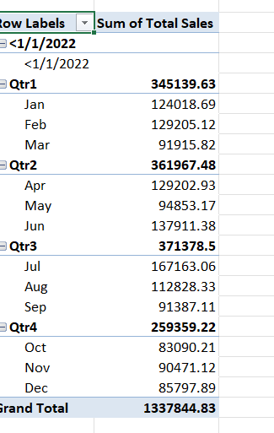
The Pivot table given above helps to understand that we have maximum sales during the 3rd quarter. We have experienced a big trough in quarter four.

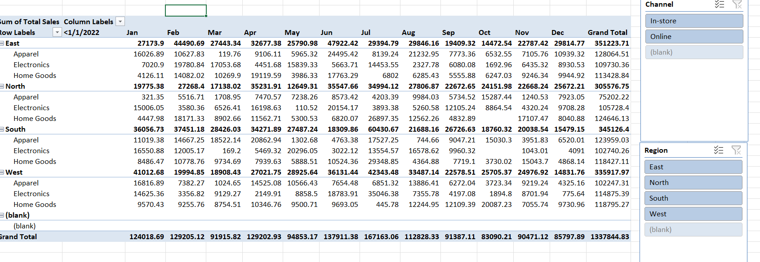

We have more achieved good sales in East region compared to other regions.

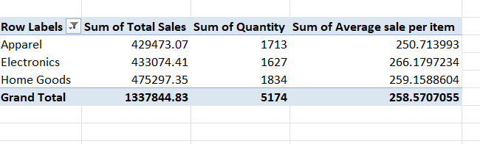
We have more average sale per item in Electronics. Home goods is towering in the total sales.

